Long term care payments are usually reported on a 1099-LTC. A sample form is shown below.
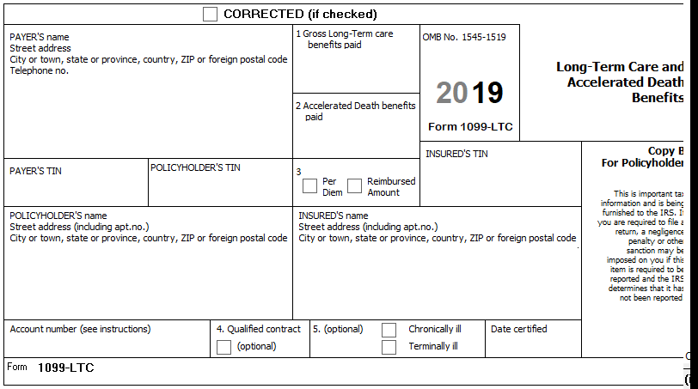
Long term care payments can be reported on a 1099-R with a box 7 distribution code of W. This code is in scope for Tax-Aide. The amount is not taxable but must be reported. Enter -0- in Box 2a of the 1099-R and--if itemizing--reduce the MAGI in the sales tax calculation by the amount in Box 1.

Long term care payments are made on a per-diem basis or as an actual reimbursement of expenses incurred.
- Per-diem plan payments are not taxable up to $360 per day. If per-diem payments received are less than $360 per day, the payments are excludible from gross income.
- Reimbursed amounts that are less than the actual cost of qualified care is excludible from gross income.

Accelerated Death Benefits under a life insurance contract are also reported on a 1099-LTC.
- Insured has been certified by a physician as terminally ill
  - Fully excludible from gross income

Certified as chronically ill
  - Treated the same as paid under a qualified long-term care insurance contract

If there are multiple payees under the insurance contract, refer the taxpayer to a paid preparer. OUT OF SCOPE
Qualified LTC Insurance Contract - A qualified LTC insurance contract is a contract issued:
- After December 31, 1996, that meets the requirements of section 7702B, including the requirement that the insured must be a chronically ill individual (defined later), or
- Before January 1, 1997, that met state law requirements for LTC insurance contracts at the time the contract was issued and has not been changed materially.
- In general, amounts paid under a qualified LTC insurance contract are excluded from your income. However, if you receive per diem payments (defined next), the amount you can exclude is limited to $360 per day.

Per Diem Payments
- Per diem payments are payments of a fixed amount made on a periodic basis without regard to actual expenses incurred. Box 3 of Form 1099-LTC should indicate whether payments were per diem payments

References:
- IRS Pub 502
- Instruction for Form 8853
- Pub 17 Chapter 5
- Pub 4012-page D40, D51

How to report 1099-LTC Payments.
• Go to the entry screen for Form 8853 (in the Adjustments section) and scroll to the Long-Term Care section. Answer the questions based on the information on Form 1099-LTC. Enter the number of days covered. The last two fields are rarely needed. Most payments will not be taxable.
Enter 8853 in TSO search box. Scroll down to the Long-Term Care (LTC) Insurance Contracts section of the form
Step 1 - Check at the top of the form indicating who holds the contract (taxpayer or spouse).
Step 2 – Enter the name and SSN of the insured
Step 3 – In 2019, did anyone other than you receive payments on a per diem or other periodic basis under a qualified LTC insurance contract covering the insured or receive accelerated death benefits under a life insurance policy covering the insured.
- If you check this box, the return is OUT OF SCOPE.

Step 4 - Was the insured a terminally ill individual?
If you check this box, follow the instructions on the form. None of the payment is taxable

Step 5 – Enter the amount in box 1 of all the 1099-LTCs if per-diem is checked in box 3 of the 1099-LTC.

Step 6 - Enter the part of the amount in Step 5 that is from qualified LTC insurance contracts. Usually shown in Box 1 of the 1099-LTC.

Step 7 – Enter the amount in box 2 of the 1099-LTC if per-diem is checked in box 3.

Step 8 – Enter the number of days in the LTC period

Step 9 – Enter actual costs incurred for qualified LTC services provided for the insured during the LTC period. Qualified LTC services are necessary diagnostic, preventive, therapeutic, curing, treating, mitigating, and rehabilitative services, and maintenance or personal care services required to treat a chronically ill individual under a plan of care prescribed by a licensed health care practitioner

Step 10 – Enter reimbursements received or expect to receive through insurance or otherwise for qualified LTC services. Box 3 checked as reimbursement amount.
Step 11 – Check the 1040 Schedule 1 line 8. If there is no amount in line 8 you are done and none of the payment is taxable. Also, review the return and find Form 8853. Line 26 should be zero.
If any of the payment is taxable, TSO will carry the taxable amount to the 1040 Schedule 1 line 8..
Any unreimbursed medical expenses can be deducted on Schedule A - Medical.
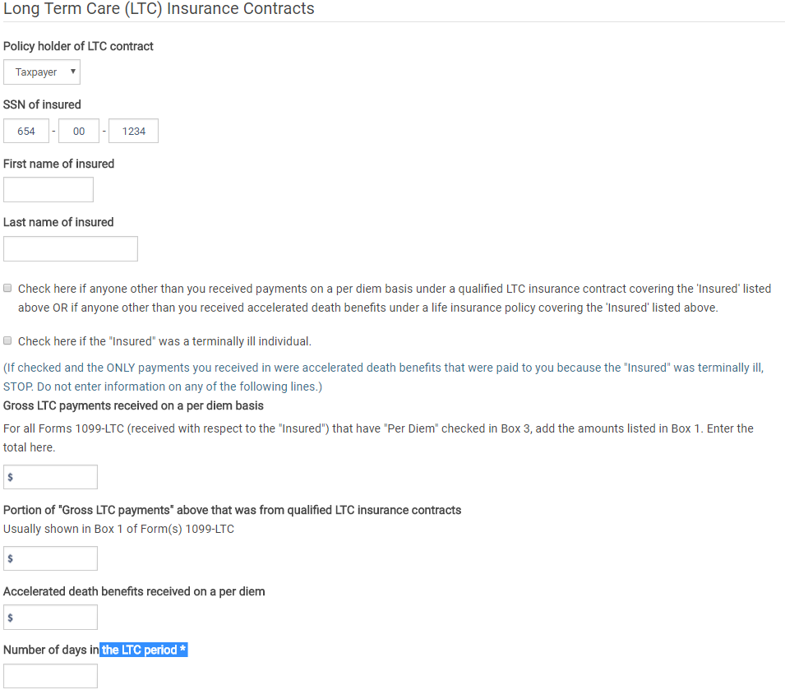
Step - 8
Step - 7
Step - 6
Step – 5
Step - 4
Step - 3
Step - 2
Step - 1
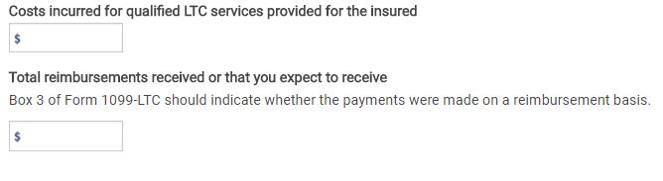
Step - 10
Step - 9

